**Online portal for tracking Seeds Record for Cultivation**

**Version 1.0**

**Group Id: S25PROJECTD16AA**

**Supervisor Name:** MIR SALAM KHAN

**Revision History**

|  |  |  |  |
| --- | --- | --- | --- |
| **Date (dd/mm/yyyy)** | **Version** | **Description** | **Author** |
| 20/07/2025 | 1.0 | This design document provides detailed descriptions and diagrams, including ERD, sequence diagrams, architecture design, class diagrams, database design, interface design, and test cases, to serve as a comprehensive blueprint for developing the Online portal for tracking Seeds Record for Cultivation | BC210424367 |
|  |  |  |  |
|  |  |  |  |
|  |  |  |  |

**Table of Content**

TASK#1 6

**Introduction of Design Document**:- 6

TASK#2 11

**Entity Relationship Diagram (ERD)** 11

TASK#3 12

**Sequence Diagrams:-** 12

**1)** **Visit the seeds portal via domain** 12

12

**2)** **Search seed categories** 13

**3)** **View seed details** 14

14

**4)** **Search seed agent profiles (Farmer / Researcher / Firm)** 15

**5)** **Place order to buy/sell seeds** 16

16

**6)** **Manage transactions and payments** 17

**7)** **Register to the portal** 18

**8)** **Log in after admin approval** 19

**9)** **Upload seed details** 20

**10)** **Log in to the system** 21

11) **Approve registered seed agents (farmers/researchers/firms)** 22

12) **View/generate analytical dashboard for Agents:-** 23

**13.** **Logout:-** 24

24

TASK#4 25

**Architecture Design Diagram:-** 25

TASK#5 26

**Class Diagram:-** 26

TASK#6 27

**Database Desigm:-** 27

TASK#7 28

**Interface Designs-** 28

**HomePage:-** 28

**Contact Us Page:-** 29

**Register Pages:-** 30

**Login Page:-** 31

**Agent Dashboard:-** 31

TASK#8 :- 32

**Test Cases** 32

EU_01: Visit the seeds portal via domain 32

EU_02: Search seed categories 32

EU_03: View seed details 32

EU_04: Search seed agent profiles 33

EU_05: Place order to buy/sell seeds 33

EU_06: Manage transactions and payments 33

SA_01: Register to the portal 34

SA_02: Log in after admin approval 34

SA_03: Upload seed details 34

SA_04: Provide contact information 35

SA_05: Provide online payment methods 35

AD_01: Log in to the system 35

AD_02: Approve registered seed agents 35

AD_03: Provide usernames and passwords 36

AD_04: View/generate analytical dashboard 36

# TASK#1

## **Introduction of Design Document**:-

This design document outlines the detailed design and architecture of the Online Community Online portal for tracking Seeds Record for Cultivation. It includes essential diagrams and descriptions that provide a comprehensive understanding of the system's structure and behavior. The primary purpose of this document is to serve as a blueprint for the development team, ensuring that all aspects of the system are well-documented and clearly defined.

1. **Entity Relationship Diagram (ERD)**

* **Entities**: Represent objects or concepts, such as that have data stored about them.
* **Relationships:** Illustrate how entities are connected
* **Attributes:**  Characteristics or properties of entities, such as User_ID for Users.
* This diagram provides a visual representation of the data model, illustrating the relationships between different entities within the system. This diagram is crucial for understanding how data is structured and interconnected.

1. **Sequence Diagrams:**

* **Objects:** Instances of classes that interact in the system.
* **Messages:** Communications between objects, shown as arrows.
* **Lifelines:** Represent the existence of an object over time.
* **Activation:** Represented by a thin rectangle or a tall, thin box, this shows when a participant is actively performing an action or operation.
* **Deactivation:** Represented by a small circle or a short, thin rectangle, this shows when a participant's action or operation is complete.
* **Conditions:** Represented by a diamond or a rectangle with a decision icon, these show the conditions or logic that govern the interactions.
* **Alternative paths:** Represented by a diamond or a rectangle with multiple outgoing arrows, these show alternative scenarios or branches.

Sequence diagrams are provided for each use case, detailing the interactions between objects over time. These diagrams help in visualizing the flow of tasks within the system and are essential for understanding the dynamic behavior of the system.

1. **Architecture Design Diagram:**

* **Layers:** Different levels of the system, such as presentation, business logic, and data access layers.
* **Components:** Functional units within each layer, like User Interface, and Database.
* **Interactions:** How layers and components communicate with each other.

The architecture design diagram presents a tiered architecture of the system, highlighting the different layers and their interactions. This section is important for understanding the overall structure and deployment of the system.

1. **Class Diagram:**

* **Classes:** Blueprints for objects, defining attributes and methods, like User, Admin.
* **Relationships:** Connections between classes, such as inheritance (Admin inherits from User), association, aggregation, and composition.
* **Attributes and Methods:** Characteristics and behaviors defined within each class. The class diagram provides a static view of the system, showing the system classes, their attributes, methods, and relationships. This diagram is fundamental for object-oriented design and development.
* **Inheritance:** Represented by an arrow pointing from a subclass to a super class, this shows the inheritance relationship between classes.
* **Composition:** Represented by a filled diamond at the end of a line connecting classes, this shows the whole-part relationship between classes.
* **Association:** Represented by a line connecting classes, this shows the relationship between classes, such as a student enrolling in a course.
* **Multiplicity:** Represented by numbers or symbols at the ends of a line connecting classes, this shows the cardinality of the relationship, such as one-to-one or many-to-many.
* **Dependencies:** Represented by a dashed arrow pointing from a dependent class to an independent class, this shows the dependency relationship between classes.
* **Interfaces:** Represented by a circle or a rectangle with a name, these define a contract or a set of operations that a class must implement.

1. %3CmxGraphModel%3E%3Croot%3E%3CmxCell%20id%3D%220%22%2F%3E%3CmxCell%20id%3D%221%22%20parent%3D%220%22%2F%3E%3CUserObject%20label%3D%22%22%20tags%3D%22Background%22%20id%3D%222%22%3E%3CmxCell%20style%3D%22vsdxID%3D1%3BfillColor%3Dnone%3BgradientColor%3Dnone%3BstrokeColor%3Dnone%3Bpoints%3D%5B%5B1%2C0.5%2C0%5D%2C%5B0.5%2C0.5%2C0%5D%2C%5B0.5%2C0%2C0%5D%5D%3BlabelBackgroundColor%3Dnone%3Brounded%3D0%3Bhtml%3D1%3BwhiteSpace%3Dwrap%3B%22%20vertex%3D%221%22%20parent%3D%221%22%3E%3CmxGeometry%20x%3D%22838%22%20y%3D%2234%22%20width%3D%22254%22%20height%3D%22401%22%20as%3D%22geometry%22%2F%3E%3C%2FmxCell%3E%3C%2FUserObject%3E%3CmxCell%20id%3D%223%22%20style%3D%22vsdxID%3D2%3BfillColor%3D%23ffffff%3BgradientColor%3Dnone%3Bshape%3Dstencil(rZBLDoAgDERP0z3SI%2Fi5B4kojQgE8Xd7IY3RuHY303lt0gGsF6OCBimWFP2kd%2BqTAWxASnJGR0pZAbaA9eCjHqNfXc8%2BqEIWNfutXDh4T5QNKU52lWDfMWrJvdA7%2FB%2F%2BC83i%2BXMga7mmd%2F7tJY%2B4U2wv)%3BstrokeColor%3D%23ffffff%3Bpoints%3D%5B%5B0%2C0.5%2C0%5D%2C%5B1%2C0.5%2C0%5D%2C%5B0.5%2C1%2C0%5D%2C%5B0.5%2C0%2C0%5D%5D%3BlabelBackgroundColor%3Dnone%3Brounded%3D0%3Bhtml%3D1%3BwhiteSpace%3Dwrap%3B%22%20vertex%3D%221%22%20parent%3D%222%22%3E%3CmxGeometry%20width%3D%22254%22%20height%3D%221%22%20as%3D%22geometry%22%2F%3E%3C%2FmxCell%3E%3CmxCell%20id%3D%224%22%20style%3D%22vsdxID%3D3%3BfillColor%3D%23d8d8d8%3BgradientColor%3Dnone%3Bshape%3Dstencil(nZBLDoAgDERP0z3SIyjew0SURgSD%2BLu9kMZoXLhwN9O%2BtukAlrNpJg1SzDH4QW%2FURgNYgZTkjA4UkwJUgGXng%2B6DX1zLfmoymdXo17xh5zmRJ6Q42BWCfc2oJfdAr%2BYv%2BAP9Cb7OJ3H%2F2JG1HNGz%2F84klThPVCc%3D)%3BstrokeColor%3D%23ffffff%3Bpoints%3D%5B%5B0%2C0.5%2C0%5D%2C%5B1%2C0.5%2C0%5D%2C%5B0.5%2C1%2C0%5D%2C%5B0.5%2C0%2C0%5D%5D%3BlabelBackgroundColor%3Dnone%3Brounded%3D0%3Bhtml%3D1%3BwhiteSpace%3Dwrap%3B%22%20vertex%3D%221%22%20parent%3D%222%22%3E%3CmxGeometry%20width%3D%22254%22%20height%3D%22401%22%20as%3D%22geometry%22%2F%3E%3C%2FmxCell%3E%3CmxCell%20id%3D%225%22%20value%3D%22%22%20style%3D%22vsdxID%3D4%3BedgeStyle%3Dnone%3Bdashed%3D1%3BdashPattern%3D2.00%202.00%3BstartArrow%3Dnone%3BendArrow%3Dnone%3BstartSize%3D5%3BendSize%3D5%3BstrokeColor%3D%23115582%3BspacingTop%3D0%3BspacingBottom%3D0%3BspacingLeft%3D0%3BspacingRight%3D0%3BverticalAlign%3Dmiddle%3Bhtml%3D1%3BlabelBackgroundC

%22600%22%20as%3D%22sourcePoint%22%2F%3E%3CmxPoint%20x%3D%22740%22%20y%3D%22550%22%20as%3D%22targetPoint%22%2F%3E%3C%2FmxGeometry%3E%3C%2FmxCell%3E%3CmxCell%20id%3D%22176%22%20value%3D%22%22%20style%3D%22endArrow%3Dnone%3Bhtml%3D1%3Brounded%3D0%3BexitX%3D0.063%3BexitY%3D0.994%3BexitDx%3D0%3BexitDy%3D0%3BexitPerimeter%3D0%3B%22%20edge%3D%221%22%20source%3D%2215%22%20parent%3D%221%22%3E%3CmxGeometry%20width%3D%2250%22%20height%3D%2250%22%20relative%3D%221%22%20as%3D%22geometry%22%3E%3CmxPoint%20x%3D%22650%22%20y%3D%22600%22%20as%3D%22sourcePoint%22%2F%3E%3CmxPoint%20x%3D%221537%22%20y%3D%22547%22%20as%3D%22targetPoint%22%2F%3E%3C%2FmxGeometry%3E%3C%2FmxCell%3E%3CmxCell%20id%3D%22177%22%20value%3D%22%22%20style%3D%22endArrow%3Dnone%3Bhtml%3D1%3Brounded%3D0%3B%22%20edge%3D%221%22%20parent%3D%221%22%3E%3CmxGeometry%20width%3D%2250%22%20height%3D%2250%22%20relative%3D%221%22%20as%3D%22geometry%22%3E%3CmxPoint%20x%3D%221491%22%20y%3D%22140%22%20as%3D%22sourcePoint%22%2F%3E%3CmxPoint%20x%3D%221716%22%20y%3D%22140%22%20as%3D%22targetPoint%22%2F%3E%3C%2FmxGeometry%3E%3C%2FmxCell%3E%3CmxCell%20id%3D%22178%22%20value%3D%22%22%20style%3D%22endArrow%3Dnone%3Bhtml%3D1%3Brounded%3D0%3BexitX%3D0.97%3BexitY%3D0.138%3BexitDx%3D0%3BexitDy%3D0%3BexitPerimeter%3D0%3B%22%20edge%3D%221%22%20source%3D%22143%22%20parent%3D%221%22%3E%3CmxGeometry%20width%3D%2250%22%20height%3D%2250%22%20relative%3D%221%22%20as%3D%22geometry%22%3E%3CmxPoint%20x%3D%221590%22%20y%3D%22640%22%20as%3D%22sourcePoint%22%2F%3E%3CmxPoint%20x%3D%221650%22%20y%3D%22640%22%20as%3D%22targetPoint%22%2F%3E%3C%2FmxGeometry%3E%3C%2FmxCell%3E%3CmxCell%20id%3D%22179%22%20value%3D%22%22%20style%3D%22endArrow%3Dnone%3Bhtml%3D1%3Brounded%3D0%3BentryX%3D0.597%3BentryY%3D1.023%3BentryDx%3D0%3BentryDy%3D0%3BentryPerimeter%3D0%3B%22%20edge%3D%221%22%20source%3D%2228%22%20target%3D%22133%22%20parent%3D%221%22%3E%3CmxGeometry%20width%3D%2250%22%20height%3D%2250%22%20relative%3D%221%22%20as%3D%22geometry%22%3E%3CmxPoint%20x%3D%22900%22%20y%3D%22480%22%20as%3D%22sourcePoint%22%2F%3E%3CmxPoint%20x%3D%22950%22%20y%3D%22430%22%20as%3D%22targetPoint%22%2F%3E%3C%2FmxGeometry%3E%3C%2FmxCell%3E%3CmxCell%20id%3D%22180%22%20value%3D%22%22%20style%3D%22endArrow%3Dnone%3Bhtml%3D1%3Brounded%3D0%3BentryX%3D0.106%3BentryY%3D0.991%3BentryDx%3D0%3BentryDy%3D0%3BentryPerimeter%3D0%3B%22%20edge%3D%221%22%20target%3D%228%22%20parent%3D%221%22%3E%3CmxGeometry%20width%3D%2250%22%20height%3D%2250%22%20relative%3D%221%22%20as%3D%22geometry%22%3E%3CmxPoint%20x%3D%221030%22%20y%3D%221110%22%20as%3D%22sourcePoint%22%2F%3E%3CmxPoint%20x%3D%221080%22%20y%3D%221060%22%20as%3D%22targetPoint%22%2F%3E%3C%2FmxGeometry%3E%3C%2FmxCell%3E%3CmxCell%20id%3D%22181%22%20value%3D%22%22%20style%3D%22endArrow%3Dnone%3Bhtml%3D1%3Brounded%3D0%3BexitX%3D0.5%3BexitY%3D0%3BexitDx%3D0%3BexitDy%3D0%3BexitPerimeter%3D0%3B%22%20edge%3D%221%22%20source%3D%2247%22%20parent%3D%221%22%3E%3CmxGeometry%20width%3D%2250%22%20height%3D%2250%22%20relative%3D%221%22%20as%3D%22geometry%22%3E%3CmxPoint%20x%3D%221839%22%20y%3D%221134%22%20as%3D%22sourcePoint%22%2F%3E%3CmxPoint%20x%3D%221825.69%22%20y%3D%22839%22%20as%3D%22targetPoint%22%2F%3E%3C%2FmxGeometry%3E%3C%2FmxCell%3E%3CmxCell%20id%3D%22182%22%20value%3D%22%22%20style%3D%22endArrow%3Dnone%3Bhtml%3D1%3Brounded%3D0%3BentryX%3D0.991%3BentryY%3D0.865%3BentryDx%3D0%3BentryDy%3D0%3BentryPerimeter%3D0%3B%22%20edge%3D%221%22%20target%3D%2233%22%20parent%3D%221%22%3E%3CmxGeometry%20width%3D%2250%22%20height%3D%2250%22%20relative%3D%221%22%20as%3D%22geometry%22%3E%3CmxPoint%20x%3D%221715%22%20y%3D%221136%22%20as%3D%22sourcePoint%22%2F%3E%3CmxPoint%20x%3D%221720%22%20y%3D%221060%22%20as%3D%22targetPoint%22%2F%3E%3C%2FmxGeometry%3E%3C%2FmxCell%3E%3CmxCell%20id%3D%22183%22%20value%3D%22%22%20style%3D%22endArrow%3Dnone%3Bhtml%3D1%3Brounded%3D0%3BentryX%3D0.022%3BentryY%3D0.958%3BentryDx%3D0%3BentryDy%3D0%3BentryPerimeter%3D0%3BexitX%3D0.007%3BexitY%3D0.205%3BexitDx%3D0%3BexitDy%3D0%3BexitPerimeter%3D0%3B%22%20edge%3D%221%22%20source%3D%2242%22%20target%3D%22133%22%20parent%3D%221%22%3E%3CmxGeometry%20width%3D%2250%22%20height%3D%2250%22%20relative%3D%221%22%20as%3D%22geometry%22%3E%3CmxPoint%20x%3D%22883%22%20y%3D%221098%22%20as%3D%22sourcePoint%22%2F%3E%3CmxPoint%20x%3D%22720%22%20y%3D%22630%22%20as%3D%22targetPoint%22%2F%3E%3C%2FmxGeometry%3E%3C%2FmxCell%3E%3CmxCell%20id%3D%22184%22%20value%3D%22%22%20style%3D%22endArrow%3Dnone%3Bhtml%3D1%3Brounded%3D0%3BentryX%3D0.28%3BentryY%3D0.987%3BentryDx%3D0%3BentryDy%3D0%3BentryPerimeter%3D0%3B%22%20edge%3D%221%22%20source%3D%2233%22%20parent%3D%221%22%3E%3CmxGeometry%20width%3D%2250%22%20height%3D%2250%22%20relative%3D%221%22%20as%3D%22geometry%22%3E%3CmxPoint%20x%3D%221378%22%20y%3D%221100%22%20as%3D%22sourcePoint%22%2F%3E%3CmxPoint%20x%3D%221651%22%20y%3D%22749%22%20as%3D%22targetPoint%22%2F%3E%3C%2FmxGeometry%3E%3C%2FmxCell%3E%3CmxCell%20id%3D%22185%22%20value%3D%22%22%20style%3D%22endArrow%3Dnone%3Bhtml%3D1%3Brounded%3D0%3BexitX%3D0.97%3BexitY%3D-0.009%3BexitDx%3D0%3BexitDy%3D0%3BexitPerimeter%3D0%3BentryX%3D0.01%3BentryY%3D-0.008%3BentryDx%3D0%3BentryDy%3D0%3BentryPerimeter%3D0%3B%22%20edge%3D%221%22%20source%3D%2238%22%20target%3D%22153%22%20parent%3D%221%22%3E%3CmxGeometry%20width%3D%2250%22%20height%3D%2250%22%20relative%3D%221%22%20as%3D%22geometry%22%3E%3CmxPoint%20x%3D%22596%22%20y%3D%22968%22%20as%3D%22sourcePoint%22%2F%3E%3CmxPoint%20x%3D%221262%22%20y%3D%22850%22%20as%3D%22targetPoint%22%2F%3E%3C%2FmxGeometry%3E%3C%2FmxCell%3E%3CmxCell%20id%3D%22186%22%20value%3D%22%22%20style%3D%22endArrow%3Dnone%3Bhtml%3D1%3Brounded%3D0%3BentryX%3D0.014%3BentryY%3D0.819%3BentryDx%3D0%3BentryDy%3D0%3BentryPerimeter%3D0%3B%22%20edge%3D%221%22%20target%3D%22101%22%20parent%3D%221%22%3E%3CmxGeometry%20width%3D%2250%22%20height%3D%2250%22%20relative%3D%221%22%20as%3D%22geometry%22%3E%3CmxPoint%20x%3D%221134%22%20y%3D%22683%22%20as%3D%22sourcePoint%22%2F%3E%3CmxPoint%20x%3D%221262%22%20y%3D%22683%22%20as%3D%22targetPoint%22%2F%3E%3C%2FmxGeometry%3E%3C%2FmxCell%3E

1. **Database Design:**

* **Tables:** Structures that store data, corresponding to entities in the ERD.
* **Columns:** Fields within tables, representing attributes.
* **Relationships:** Connections between tables, implemented via foreign keys. The database design section includes diagrams that detail the schema of the database, ensuring that the data is organized efficiently and supports the application's requirements.

1. **Interface Design:**

* **Screenshots:** Visual representations of the user interface.
* **Layouts:** Arrangement of elements on the screen.
* **User Interactions:** How users interact with the interface.
* **Accessibility:** A description of the accessibility features and considerations, including WCAG guidelines and screen reader support.
* **Responsive Design:** A description of the responsive design approach, including breakpoints, layouts, and media queries.
* **Design Rationale:** A explanation of the design decisions, including the reasoning behind the design choices.

This section provides screenshots of the system's graphical user interface (GUI). It show cases the main interfaces, demonstrating the application's most important features and how users will interact with the system.

**8. Test Cases:**

* **Test Scenarios:** Specific situations to be tested.
* **Test Steps:** Detailed actions to perform the test.
* **Expected Results:** Anticipated outcomes of the test.

Test cases for each use case scenario are provided to ensure that the system's functionality is thoroughly tested. This section is vital for validating the system against its requirements and ensuring its reliability.

**Benefits and Purpose of the Design Phase:**

The design phase in a software development project is critical for several reasons:

* **Clarity and Communication:** It provides a clear and shared understanding of the system among all stakeholders, including developers, designers, and clients.
* **Blueprint for Development:** It serves as a detailed blueprint that guides the development process, ensuring that all components are developed in a coherent and consistent manner.
* **Risk Mitigation:** By defining the system architecture and design early potential issues can be identified and addressed before implementation begins, reducing risks and avoiding costly changes later.
* **Quality Assurance:** Detailed design documentation supports rigorous testing and validation, helping to ensure that the final product meets the specified requirements and standards.
* **Scalability and Maintenance:** A well-thought-out design facilitates future scalability and ease of maintenance, allowing the system to evolve with changing requirements.

This document is instrumental in ensuring the successful development and deployment of Online portal for tracking Seeds Record for Cultivation, providing a solid foundation for building a robust, efficient, and user-friendly application.

# TASK#2

## **Entity Relationship Diagram (ERD)**

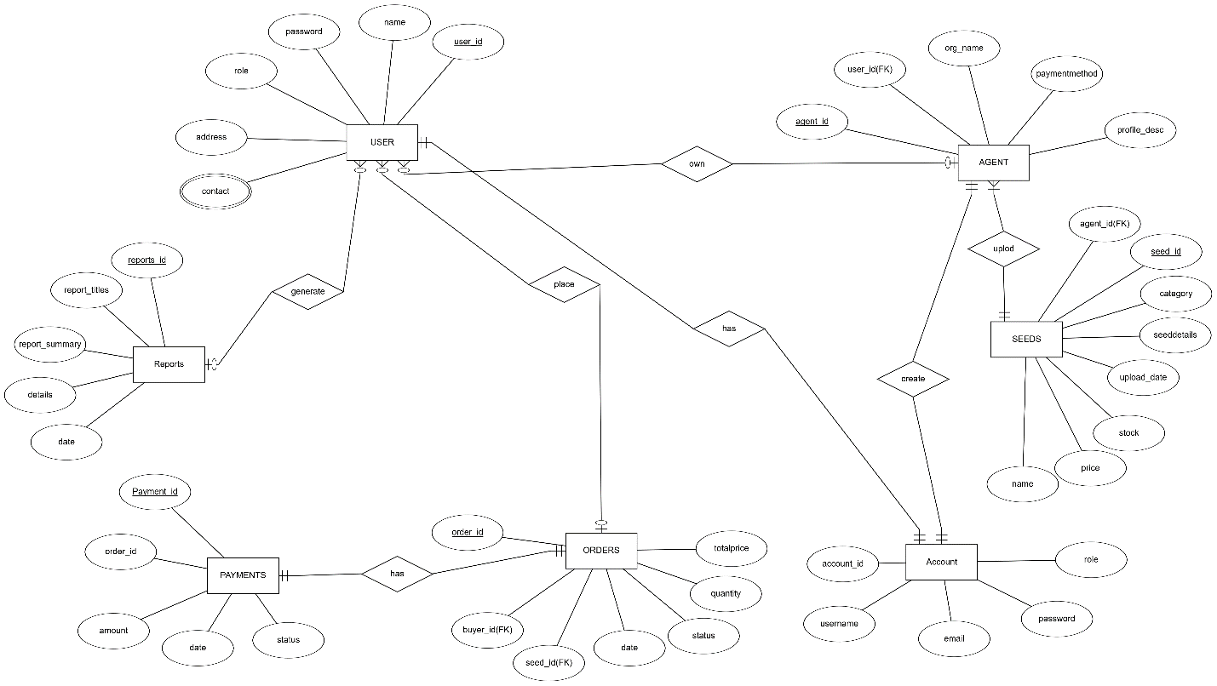

**Diagram 1**

# TASK#3

## **Sequence Diagrams****:-**

1. **Visit the seeds portal via domain**

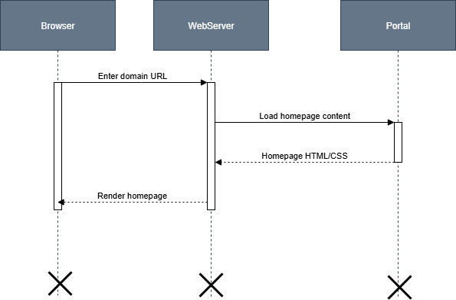

**Diagram 2**

1. **Search seed categories**

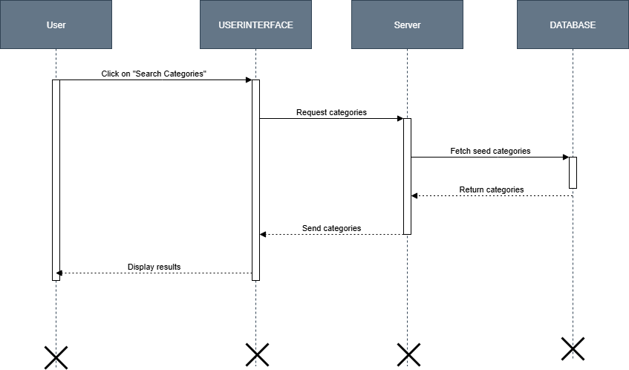

**Diagram 3**

1. **View seed details**

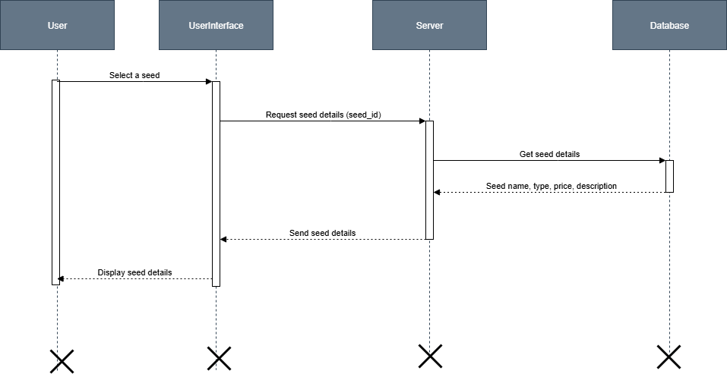

**Diagram 4**

1. **Search seed agent profiles (Farmer / Researcher / Firm)**

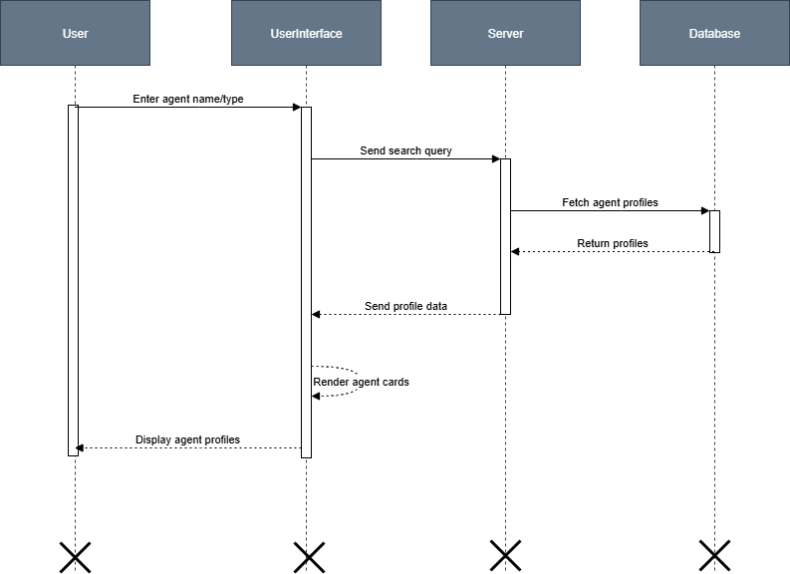

**Diagram 5**

1. **Place order to buy/sell seeds**

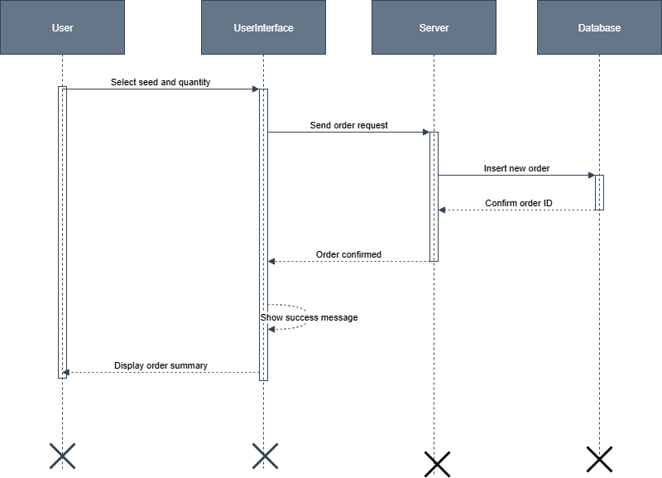

**Diagram 6**

1. **Manage transactions and payments**

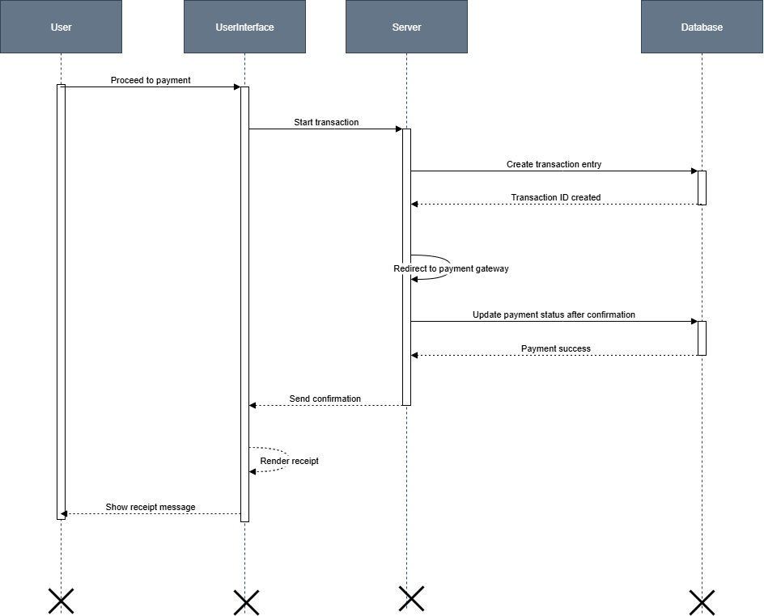

**Diagram 7**

1. **Register to the portal**

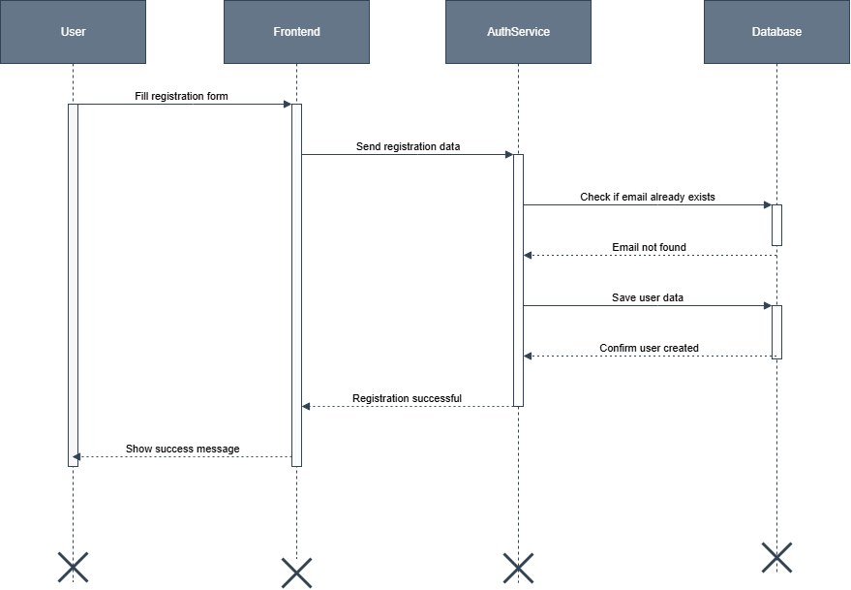

**Diagram 8**

1. **Log in after admin approval**

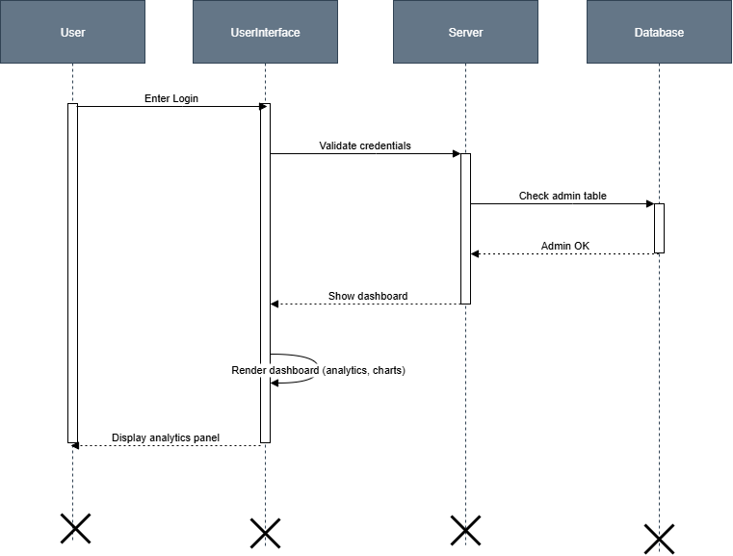

**Diagram 9**

1. **Upload seed details**

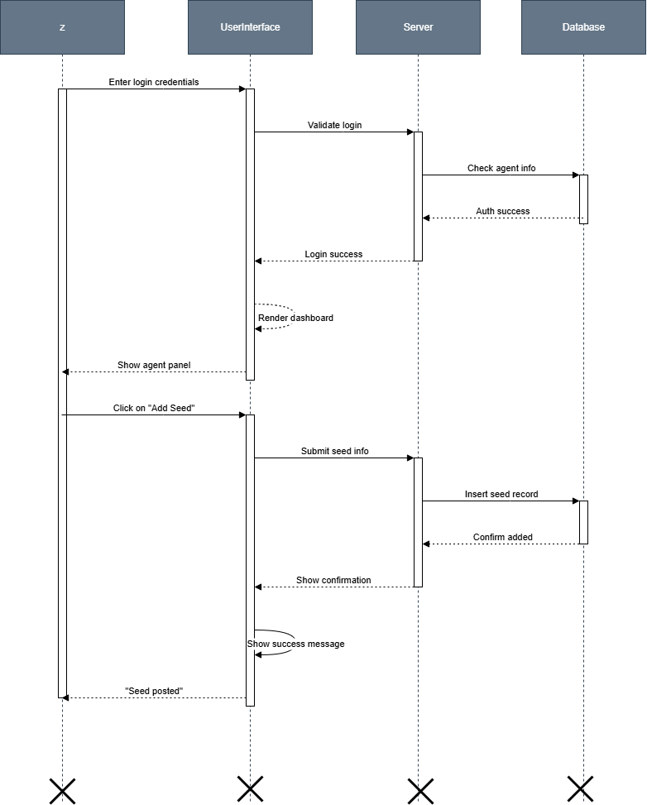

**Diagram 10**

1. **Log in to the system**



**Diagram 11**

1. **Approve registered seed agents (farmers/researchers/firms)**

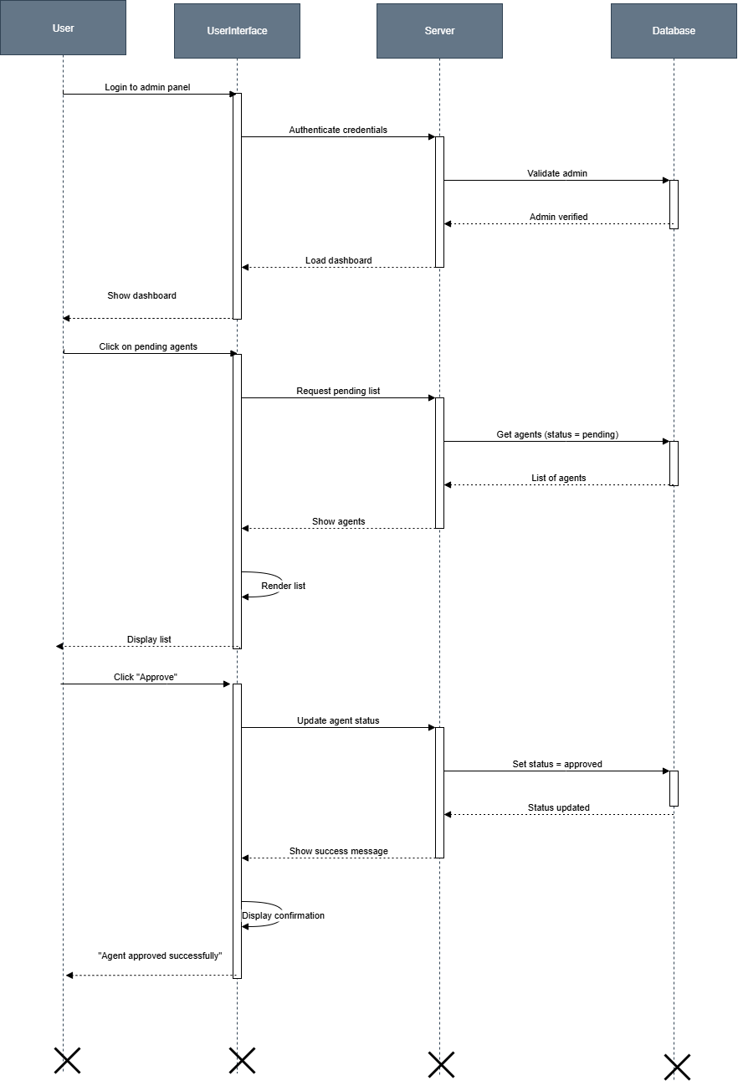

**Diagram 12**

1. **View/generate analytical dashboard for Agents:-**

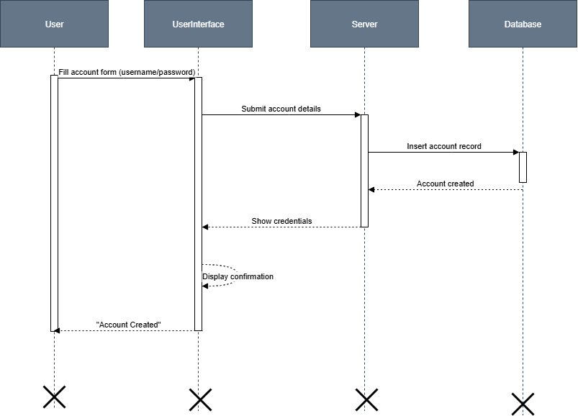

**Diagram 13**

### **Logout:-**

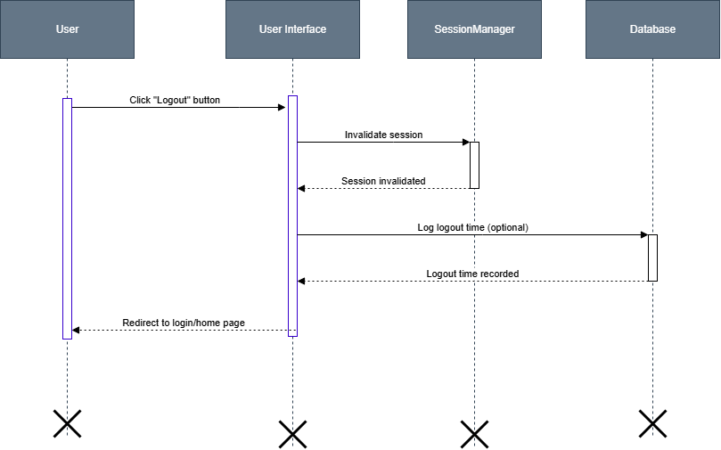

**Diagram 13**

# TASK#4

## **Architecture Design Diagram:-**

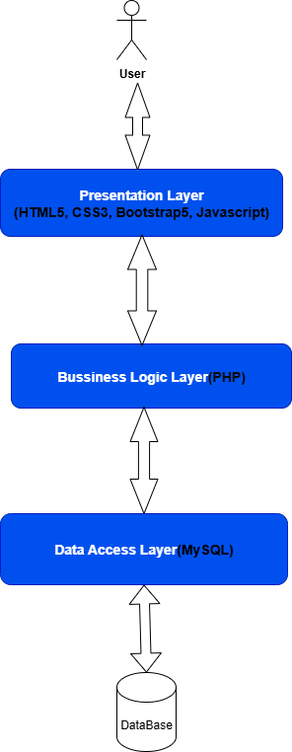

**Diagram 14**

# TASK#5

## **Class Diagram:-**

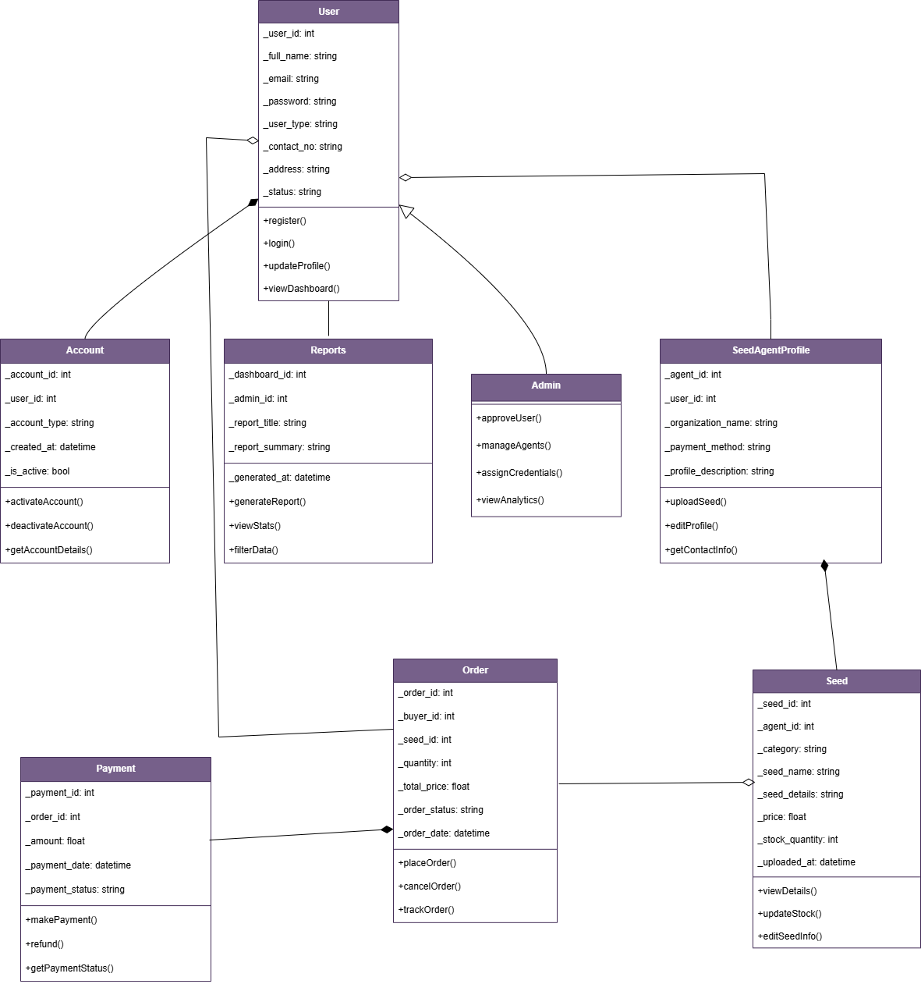

**Diagram 15**

# TASK#6

### **Database Desigm:-**

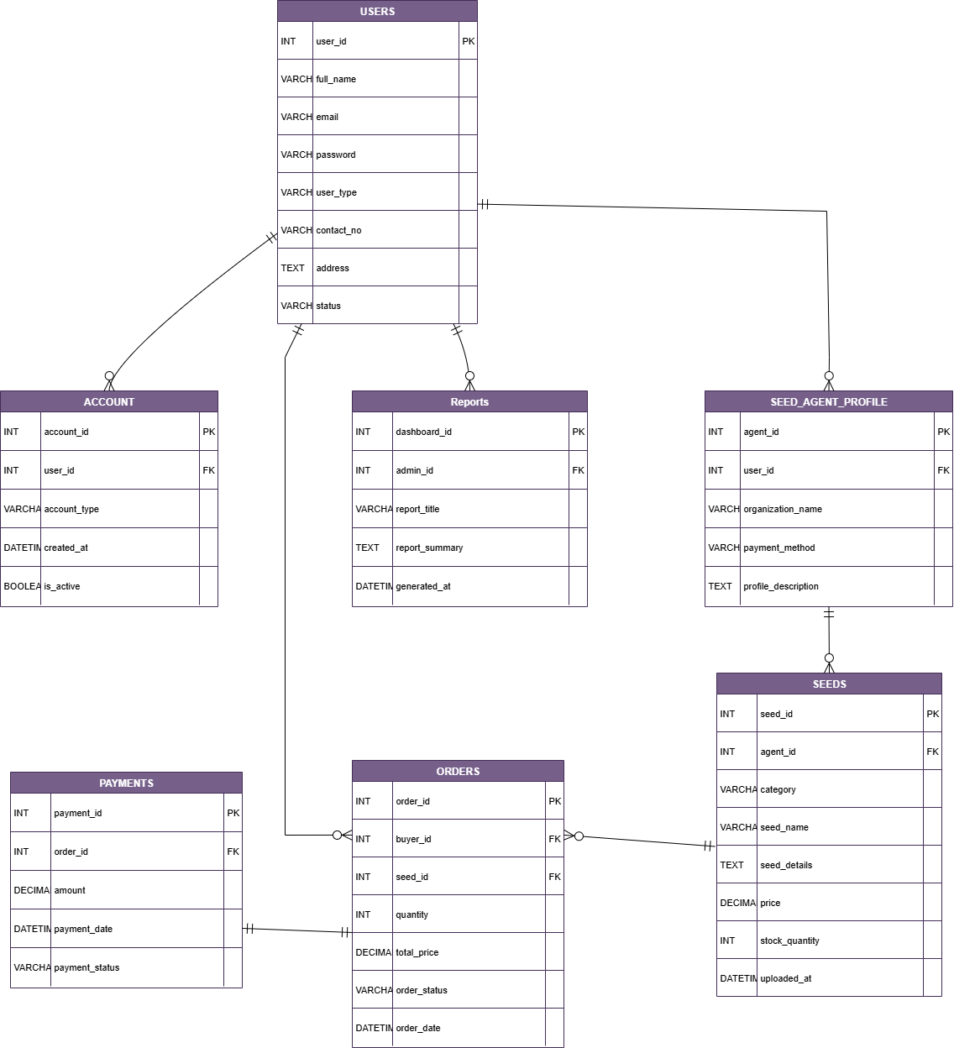

**Diagram 16**

# TASK#7

## **Interface Designs-**

### **HomePage:-**

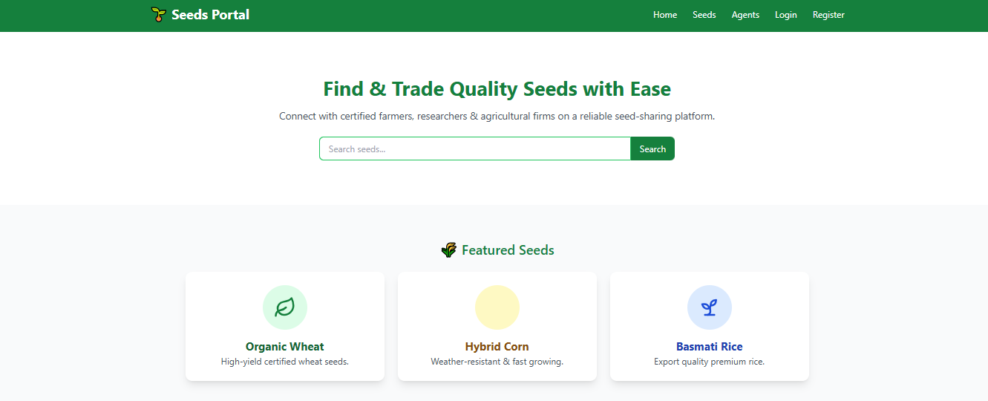

### **Contact Us Page:-**

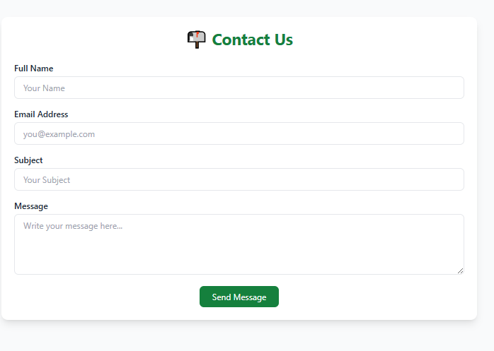

### **Register Pages:-**

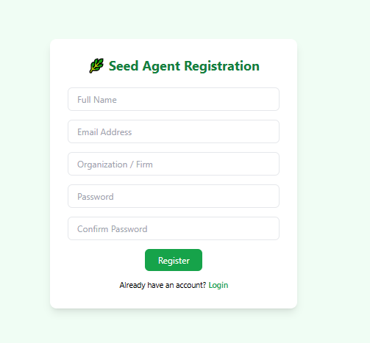

### **Login Page:-**

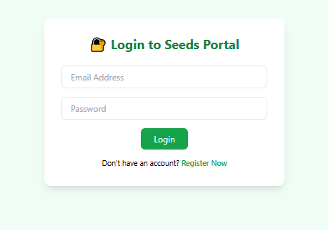

### **Agent Dashboard:-**

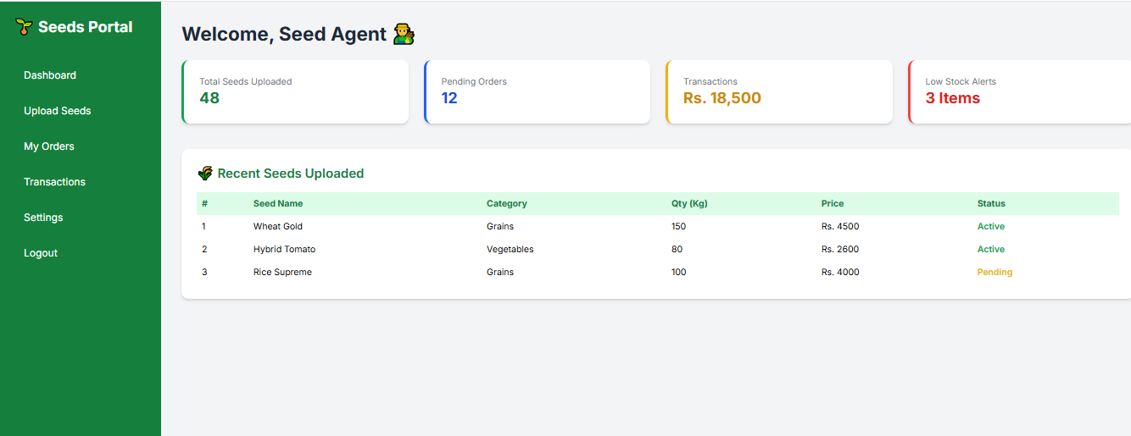

# TASK#8 :-

## **Test Cases**

Seeds Portal Project - Complete Test Cases

## EU_01: Visit the seeds portal via domain

|  |  |
| --- | --- |
| Test Case ID | EU_01 |
| Test Case Name | Visit the seeds portal via domain |
| Description | Verify the end-user can access the portal using the domain URL. |
| Test Steps | 1. Open browser 2. Enter portal domain 3. Hit Enter |
| Test Data | Domain URL |
| Expected Results | Portal homepage should load successfully |
| Test Result | Yes |
| Tested By | BC210424367 |

## EU_02: Search seed categories

|  |  |
| --- | --- |
| Test Case ID | EU_02 |
| Test Case Name | Search seed categories |
| Description | Verify the end-user can search available seed categories. |
| Test Steps | 1. Login to portal 2. Use category search bar 3. View results |
| Test Data | Category = 'Wheat' |
| Expected Results | Relevant seed categories displayed |
| Test Result | Yes |
| Tested By | BC210424367 |

## EU_03: View seed details

|  |  |
| --- | --- |
| Test Case ID | EU_03 |
| Test Case Name | View seed details |
| Description | Check that user can view complete seed details. |
| Test Steps | 1. Search seed 2. Click seed result 3. View details page |
| Test Data | Seed name = 'Hybrid Rice' |
| Expected Results | Full details about the seed shown |
| Test Result | Yes |
| Tested By | BC210424367 |

## EU_04: Search seed agent profiles

|  |  |
| --- | --- |
| Test Case ID | EU_04 |
| Test Case Name | Search seed agent profiles |
| Description | Verify end-user can search and view seed agent profiles. |
| Test Steps | 1. Use agent search feature 2. View agent list 3. Click on agent name |
| Test Data | Agent type = 'Researcher' |
| Expected Results | Profile page of selected agent shown |
| Test Result | Yes |
| Tested By | BC210424367 |

## EU_05: Place order to buy/sell seeds

|  |  |
| --- | --- |
| Test Case ID | EU_05 |
| Test Case Name | Place order to buy/sell seeds |
| Description | Check if user can place an order to buy or sell seeds. |
| Test Steps | 1. Search seed 2. Click 'Order' button 3. Enter details and submit |
| Test Data | Seed ID, Quantity, Mode=Buy |
| Expected Results | Order placed successfully and confirmation shown |
| Test Result | Yes |
| Tested By | BC210424367 |

## EU_06: Manage transactions and payments

|  |  |
| --- | --- |
| Test Case ID | EU_06 |
| Test Case Name | Manage transactions and payments |
| Description | Verify user can view and manage payment transactions. |
| Test Steps | 1. Go to transaction page 2. Select order 3. Initiate payment |
| Test Data | Order ID, Card Info, Amount |
| Expected Results | Payment processed and confirmation displayed |
| Test Result | Yes |
| Tested By | BC210424367 |

## SA_01: Register to the portal

|  |  |
| --- | --- |
| Test Case ID | SA_01 |
| Test Case Name | Register to the portal |
| Description | Check seed agent can register by submitting required info. |
| Test Steps | 1. Open registration page 2. Fill details 3. Submit form |
| Test Data | Name, Email, Password, Role=Farmer |
| Expected Results | Registration request submitted for admin approval |
| Test Result | Yes |
| Tested By | BC210424367 |

## SA_02: Log in after admin approval

|  |  |
| --- | --- |
| Test Case ID | SA_02 |
| Test Case Name | Log in after admin approval |
| Description | Verify that approved agent can log in to the portal. |
| Test Steps | 1. Open login page 2. Enter credentials 3. Click login |
| Test Data | Email, Password |
| Expected Results | Redirected to agent dashboard |
| Test Result | Yes |
| Tested By | BC210424367 |

## SA_03: Upload seed details

|  |  |
| --- | --- |
| Test Case ID | SA_03 |
| Test Case Name | Upload seed details |
| Description | Ensure agent can upload seed information. |
| Test Steps | 1. Login as agent 2. Navigate to upload section 3. Enter and submit seed data |
| Test Data | Seed name, Description, Price, Quantity |
| Expected Results | Seed uploaded and visible in listings |
| Test Result | Yes |
| Tested By | BC210424367 |

## SA_04: Provide contact information

|  |  |
| --- | --- |
| Test Case ID | SA_04 |
| Test Case Name | Provide contact information |
| Description | Verify agent can update contact details. |
| Test Steps | 1. Login 2. Go to profile 3. Edit and save contact info |
| Test Data | Phone, Address, Email |
| Expected Results | Contact details updated successfully |
| Test Result | Yes |
| Tested By | BC210424367 |

## SA_05: Provide online payment methods

|  |  |
| --- | --- |
| Test Case ID | SA_05 |
| Test Case Name | Provide online payment methods |
| Description | Verify seed agent can configure payment methods. |
| Test Steps | 1. Login 2. Go to payment settings 3. Add method |
| Test Data | Payment Type = 'JazzCash', Account Info |
| Expected Results | Payment method saved successfully |
| Test Result | Yes |
| Tested By | BC210424367 |

## AD_01: Log in to the system

|  |  |
| --- | --- |
| Test Case ID | AD_01 |
| Test Case Name | Log in to the system |
| Description | Verify that admin can log in using credentials. |
| Test Steps | 1. Open login page 2. Enter admin credentials 3. Click login |
| Test Data | Email, Password |
| Expected Results | Redirected to admin dashboard |
| Test Result | Yes |
| Tested By | BC210424367 |

## AD_02: Approve registered seed agents

|  |  |
| --- | --- |
| Test Case ID | AD_02 |
| Test Case Name | Approve registered seed agents |
| Description | Check admin can approve new agent registrations. |
| Test Steps | 1. Login as admin 2. Go to approval section 3. Approve pending agents |
| Test Data | Agent ID, Status = 'Approved' |
| Expected Results | Agent account status updated |
| Test Result | Yes |
| Tested By | BC210424367 |

## AD_03: Provide usernames and passwords

|  |  |
| --- | --- |
| Test Case ID | AD_03 |
| Test Case Name | Provide usernames and passwords |
| Description | Verify admin can assign login credentials to approved agents. |
| Test Steps | 1. Login as admin 2. Go to user management 3. Assign username and password |
| Test Data | Agent ID, Username, Password |
| Expected Results | Credentials assigned successfully |
| Test Result | Yes |
| Tested By | BC210424367 |

## AD_04: View/generate analytical dashboard

|  |  |
| --- | --- |
| Test Case ID | AD_04 |
| Test Case Name | View/generate analytical dashboard |
| Description | Check admin can view and generate analytics from dashboard. |
| Test Steps | 1. Login as admin 2. Go to dashboard 3. Select analytics option |
| Test Data | Date Range = 'Last 30 days' |
| Expected Results | Analytics displayed successfully |
| Test Result | Yes |
| Tested By | BC210424367 |